# Project Title: **SoulJournal**

Full Name: Alexandru Georgescu

# Date (mm/dd/yyyy): 25/06/2024

# Recipient Organization:

Course Title: [**HDSDEV_SEP23**](https://moodle2023.ncirl.ie/user/view.php?id=22353&course=634)

# Interim Progress report

1. Project Overview
   1. **Background**

“[Research](https://journals.sagepub.com/doi/abs/10.1177/0146167201277003) by Laura King shows that writing about achieving future goals and dreams can make people happier and healthier. Similarly, Jane Dutton and Gregory Ciotti [found](https://journals.sagepub.com/doi/abs/10.1177/0956797612439424) that when people doing stressful fundraising jobs kept a journal for a few days about how their work made a difference, they increased their hourly effort by 29% over the next two weeks.” ([Source](https://www.helpscout.com/blog/benefits-of-writing/))

A web-based journaling application also offers unparalleled convenience, allowing users to journal from any device with internet access. This flexibility is particularly appealing in today’s fast-paced world, where individuals seek tools that fit seamlessly into their busy lifes.

* 1. **Objective**

The objective for this project is to build a journaling web application called **SoulJournal**. The app will be designed to provide users a convenient, customizable, and secure platform for personal journaling. **SoulJournal** will look for individuals who seek to improve their mental health, enhance self-reflection, and foster personal growth through regular journaling.

* 1. **Market Comparison**

**SoulJournal** targets a specific market of individuals who are looking for a digital alternative to traditional pen-and-paper journaling. The goal is to offer a more accessible, flexible, and interactive journaling experience.

Popular Journaling Apps in the Market:

* + 1. [**DayOne**](https://www.dayone.com/)
       1. Features:
          1. Offers multimedia entries, including photos and videos
          2. Provides end-to-end encryption for security
       2. Pricing:
          1. Free tier with basic features
          2. Premium subscription starting at $2.92/month
    2. [**Penzu**](https://www.penzu.com/)**:**
       1. Features:
          1. Customziable journal covers
          2. Web and mobile access
       2. Pricing:
          1. Free tier with basic features
          2. Premium subscription starting at $4.99/month

While the above mentioned apps provide robust journaling features, **SoulJournal** aims to differentiate itself in several key areas:

* + **SoulJournal** will offer a high degree of customization in terms of journal themes, fonts, and layouts, allowing users to personalize their journaling experience extensively.
  + Unlike other apps, **SoulJournal** will feature a built-in inspirational quote generator using the ZenQuotes API, providing daily motivation directly within the app.

The web-based nature of **SoulJournal** ensures that users can access their journals from any device with internet connectivity, without the need for additional downloads or installations.

1. **Project expected deliverables**

In the completion of this project a number deliverables are to be submitted.

* 1. **Documents**

The documents are required for this project are outlined in the table below(**fig 2.1**). The project is 40% completed and we expect that the documents will be delivered in accordance with the deadlines.

|  |  |  |  |
| --- | --- | --- | --- |
| Document | Description | Date Due | Submitted |
| Project Proposal | A document that outlines the project idea. | 8th June | Yes |
| Ethics Approval Form | A series of questions which aim to help identify if the project is “high risk” and requires for review by ethics committee | 8th June | Yes |
| Signed Project Brief | A document that outlines the project submission dates and the marking of the project | 8th June | Yes |
| Project Requirement Specification | A document that describes what the application will do and how it is expected to perform. | 22nd June | Yes |
| Interim Report | A report on the current status of the project. | 29th June | No |
| Project Analysis & Design Documentation | A document that outlines the system design and architecture of the application. | 20th July | No |
| Project Final Report | A document that describes all categories of the project | 10th August | No |
| Declaration Cover Sheet | A document that confirms that this project is all my own work. | 10th August | No |
| Project Code | The application code | 10th August | No |
| Video of Final Project | A quick video presentation showing all the features of the completed application | 10th August | No |

Figure 2.1: Table showing the documentation deliverables

* 1. **Application Functionality**
     1. **User Registration**
        + Users can enter their details to register. Registered users can log in, create, and manage journal entries, customize their journal, and access additional features like goal setting and motivational content.
     2. **Secure Login**
        + Registered users can securely log in with their email and password.
     3. **Journal Entry Management**
        + Users can create, edit, and delete journal entries, organize them by date, and search past entries.
     4. **Customization Options**
        + Users will have the ability to customize the appearance of their journal, including choosing different themes and fonts. This personalization will help users feel more connected to their journaling experience and increase engagement with the app.
     5. **Motivational Content**
        + The app will provide users with daily motivational quotes.
     6. **Feedback Mechanism**
        + This will help in continuous improvement of the system based on user input.

1. **Project actual targets met**
   1. **Documents to date**
      * At the time of writing this document, we have for documents that will be submitted:
        1. Project Proposal
        2. Ethics Approval Form
        3. Project Requirement Specification
        4. Interim Report
   2. **Wireframes**

Our plan is to adopt a mobile-first approach for the **SoulJournal** web application. The reasons behind this are:

* + - * **Increased Mobile Usage:** The majority of users today access web applications via mobile devices. Designing for mobile first ensures that the app is accessible and functional on the most widely used devices.
      * **Improved User Experience:** A mobile-first approach will prioritize the essential features and content, leading to a cleaner and more efficient user interface.
      * **Enhanced Performance:** Mobile-first design often results in a more performant and faster-loading application. By focusing on mobile constraints from the beginning, we ensure that the app is optimized for speed and efficiency.

The wireframes for **SoulJournal** can be seen below:

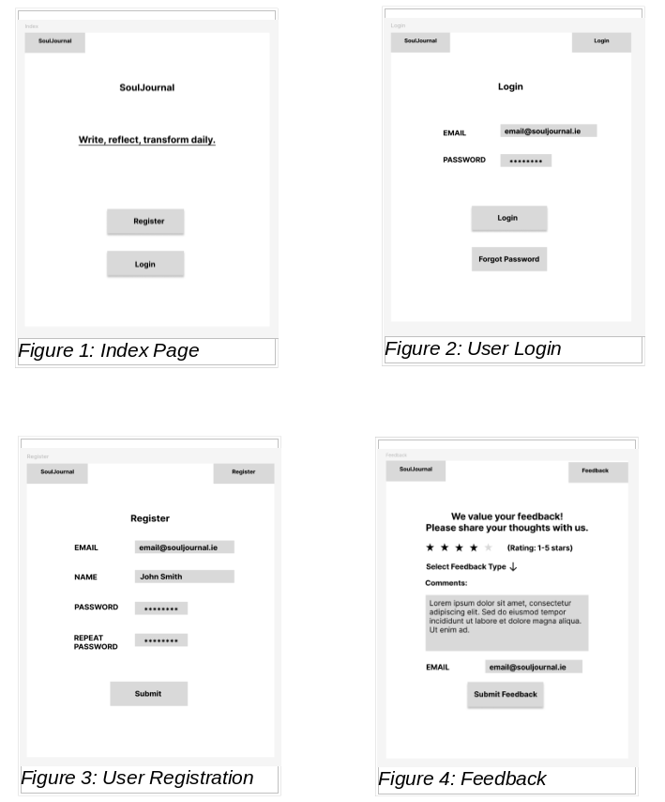

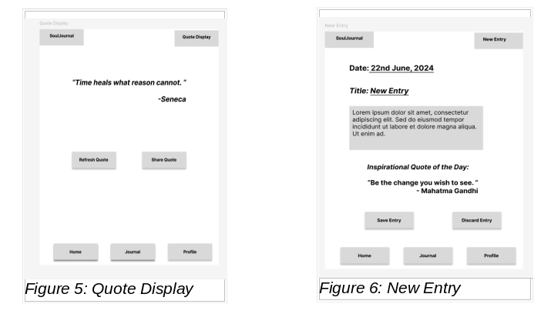

* 1. **Integration of** [**ZenQuotes**](https://zenquotes.io/) **API**

To enhance the user experience, the **SoulJournal** web application will also integrate the ZenQuotes API.

The integration will allow users to receive a daily does of inspiration within their journaling environment.

* + 1. **API Selection and Integration:**
    - **API Overview:** ZenQuotes API can be a reliable source for high-quality quotes.
      * **API Endpoint:** The ZenQuotes API provides a simple endpoint for retrieving random quotes or quotes from specific categories. The endpoint used will be [here](https://zenquotes.io/api/random).
    1. **Fetching Quotes**
       - HTTP Requests**:** The application will make HTTP GET requests to the ZenQuotes API to fetch quotes. This will be handled using a JavaScript library such as Axios or the Fetch API.
    - Data Parsing: Once the quote data is received in JSON format, it will be parsed and integrated into the user interface.
    1. **Displaying Quotes**
       - Daily Quotes**:** Users will see a new quote each day on their dashboard or journal entry page. This will be implemented using a scheduled job or a simple timestamp check to update the quote daily.
    - Custom Quotes: Users can also request a new quote at any time by clicking a "Refresh Quote" button, which will trigger a new API call to fetch a fresh quote.
  1. **System Architecture**

The **SoulJournal** web application will be developed using JavaScript for the front-end and back-end, with additional technologies to support the system. The chosen technology stack will include MongoDB for the database, Bootstrap for the front-end design and will also include Node.js and Express.js for the server-side framework.

**Technologies:**

1. **JavaScript**
   * Front-end: JavaScript will be used to create a dynamic and interactive user interface
   * Back-end: Node.js with Express.js will handle server-side operations
2. **BootStrap**
   * Bootstrap will be utilized to create a responsive and mobile-first design
3. **MongoDB**
   * Database: MongoDB, a NoSQL database, will be used for storing user data and journal entries.

Figure 3.4.1: System Architecture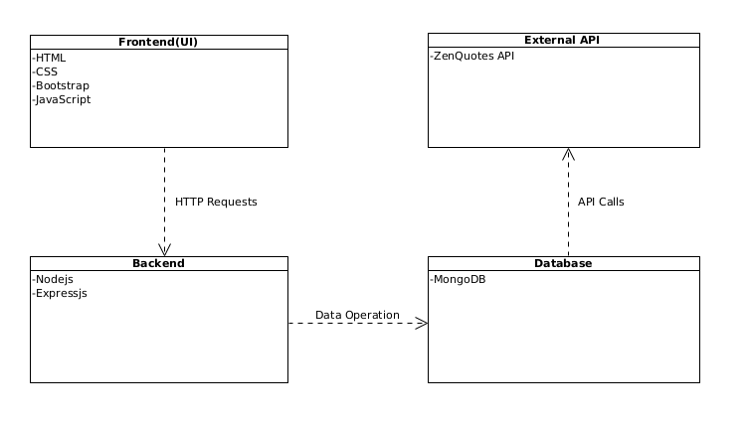

* 1. **Current development of SimpleFocals web application**

I am currently in the process of building the **SoulJournal** web application. As outlined in the Application Functionality section of this document, I am developing the project in terms of components that will combine together to make the complete system.

At present, I am focusing on establishing the core structure of the application and conceptualizing the layout, theme, and font choices to ensure a cohesive and visually appealing user interface.

I have started by researching Node.js and Express.js for backend, and MongoDB for the database. I have also begun looking for the integration of ZenQuotes API to fetch and display daily inspirational quotes on the homepage.

For the frontend I will be using Bootstrap to create a responsive interface. I am currently working on the initial wireframes, refining the design elements and ensuring that the layout meets the project’s requirements.

I have also started using MongoDB and create initial tables to store user data and journal entries, watching courses on this subject and get myself accustomed with it.

When users log into the system, they will be greeted with a homepage that displays their journal entries and daily inspirational quotes from the ZenQuotes API.

My progress on the subject has been delayed because the project idea I selected proved to be too challenging for me to implement. Despite the delay, I was able to recover and find an idea for the project.

1. **Deliverables yet to be achieved.**

Despite the progress made in the research, requirements capture, and architecture design phases of the **SoulJournal** web application, several key deliverables remain outstanding. Below is an outline of the deliverables:

* + **User Authentication System**
  + **Journal Entry Management**
  + **Integration with ZenQuotes API**
  + **Frontend Development and UI/UX Design**
  + **Data Storage**
  + **Testing and Quality Assurance**

Although we still have several deliverables that are still outstanding, each one is within reach given the structured approach. By prioritizing tasks and adhering to the module guidelines, I am confident in achieving these goals and delivering a functional **SoulJournal** web application.

* 1. **Documents/Materials**

In the table(Figure 2.1) there are still documents and materials that have not been submitted.

At this point, we have the following:

* **Project Analysis and Design Documentation**
* **Declaration Cover Sheet**
* **Project Final Report**
* **Project Code**
* **Final Video Presentation**
  1. **Application Development**

In terms of development, I plan of having all the components done before the final submission. The order of the components is:

1. **User Authentication and Authorization**
   * Implement a secure login system using authentication and authorization.
2. **Journal Entry Management**
   * Develop functionalities that will allow the user to create, edit, and delete their journal entries.
3. **ZenQuotes API Integration**

* Implement the integration of **ZenQuotes** API to display inspirational quotes on the user’s dashboard to enhance their journaling experience

1. **User Personalization Features**

* Implement features for users to customize the look and feel of their journal entries, including themes, and layout options.

1. **Feedback System**
   * Develop a feedback system that allows users to provide feedback on their journaling experience and suggest improvements.

In combination with implementing these components, I will concurrently develop the website front-end using Bootstrap to ensure responsiveness and an intuitive user interface. This will allow for continuous testing and integration of each component as it is developed. Once all components are implemented, I will ensure the web application functions as a whole system.

1. **Main problems encountered**
   1. **Understanding the functionalities of the frameworks/technologies**

To be honest, this project is my first experience working with web development frameworks and technologies. Through this project, I have been able to research and experiment with various technologies including JavaScript, Bootstrap, Node.js, Express.js and MongoDB.

* **Learning JavaScript and Bootstrap**

I have completed basic tutorials on JavaScript and Bootstrap. Although I’ve had a module on Web Development that included HTML, CSS and JavaScript, if you don’t constantly use that language, you will usually forget all in less than 3 months. The tutorials that I’ve tried covered setting up a basic project, creating interactive elements using JavaScript, and also developing responsive front-end designs with Bootstrap. While these tutorials provided a good introduction, my understanding of these technologies remains limited.

* **Exploring Node.js and Express.js**

Working with Node.js and Express.js has been a significant learning experience. I have set up a basic Node.js project, created RESTful APIs with Express.js. At the moment I’m trying to also connect these to a MongoDB database to perform CRUD operations. Even though it’s not great and I’m not successful into it, I’m looking forward to any challenges that occur.

* **Understanding MongoDB**

In terms of database management, I’m trying to utilize MongoDB for storing and retrieving data. Basic operations such as inserting, updating, and deleting documents are starting to make sense to me.

* 1. **Time Constraints**

I have faced several challenges with time management during this project. Additionally, I had to rethink and select a new project idea, which significantly delayed my progress.

Furthermore, as someone with ADHD and Autism, I encounter unique challenges in maintaining focus and managing time effectively. These conditions can make it difficult to adhere to a strict schedule, but they also drive me to develop strategies for problem-solving. Despite these challenges, I am determined to ensure that the project is completed on time.

* 1. **Debugging Problems in the Project**

Developing this web application has been my first extensive experience using JavaScript, Node.js, Express.js, and integrating other technologies like Bootstrap and MongoDB. As someone that isn’t used to this technologies, I often found myself trying to troubleshoot the issues.

To address these issues, I frequently turned to both Google and ChatGPT for solutions. While ChatGPT provided some useful guidance, I found that Google searches often led me to forums and community discussions where other developers had faced similar problems. These discussions were particularly valuable because they included detailed explanations, step-by-step solutions, and insights from multiple experienced developers who had already worked through similar issues. This human element and the ability to see a variety of perspectives and approaches were instrumental in resolving many of t he complex problems I encountered.

1. **Expected Stumbling Blocks**
   1. **Implementation**

As this is my first experience building a full web application using JavaScript and related frameworks, I anticipate facing some challenges during development. While I have completed tutorials to gain a hands-on understanding of implementation, these were often step-by-step guides that may not fully prepeare me for the complexities of building a complete application.

I expect to encounter problems in the development phase as more complicated functionality is required. Some potential stumbling blocks:

* Asynchronous operations and API integration
* Implementing secure user authentication
* Handling real-time updates for features like quotes

I believe I will be able to overcome these stumbling blocks with more experience developing in this environment, consulting documentation, and seeking help from online communities when needed.

* 1. **Time Constraints**

To manage the development process effectrively, I have updated my project plan by dividing the implementation of the **SoulJournal** application into components. These components will combine to form the whole system. The main components include:

* User authentication (registration and login)
* Journal entry management
* Quote integration
* Feedback system
* User interface and styling

Since this is my first time creating such an application, I expect that some components may take longer to implement than initially anticipated. This could lead to time constraints, especially towards the end of the project timeline.

* 1. **Presentation**

I am confident and enjoy giving presentations. I expect the final presentation will be an opportunity to showcase my work effectively. Although I don’t mind towards presenting, I still see room for improvement and aim to refine my skills further. Strong communication skills are particularly important in software development, as they help collaboration in team situations.

1. **Focus on rubric**
   1. **Communication**

As previously mentioned, i enjoy the presentation part of this project. To prepare for the final presentation, I plan to create a PowerPoint presentation, structure the content in a logical flow, and ensure I have detailed notes for each section. I will also try to deliver my presentation smoothly by preparing efficiently and practicing multiple times.

* 1. **Writing and presentation of results**

For the documentation of this project, I aim to write in a clear and concise manner. I will provide examples where applicable and support any assumptions with relevant information. If needed, I will use tables, diagrams, or images to display information, ensuring they are labeled and numbered through all documents.

* 1. **Complexity/Coding skills**

The implementation of different frameworks and technologies in this project presents, for me, a significant challenge. This project does require indeed a lot of self-study and research. The requirements I have set for myself are complex, especially taking into consideration the fact that it is my first time using technologies like Node.js, Express.js and MongoDB.

* 1. **Innovation**

**SoulJournal** aims to provide users with a seamless and engaging platform for personal journaling, enriched with motivational quotes from the ZenQuotes API. As there are many other apps on the market that do this, we aim to be different by implementing different themes and layouts that would attract users.

* 1. **Technology**

This project is being developed using Node.js and Express.js for the backend, MongoDB for the database, and a combination of HTML, CSS, JavaScript, and Bootstrap for the front-end.

* 1. **Completeness**

Upon completion of this project, the **SoulJournal** web application will facilitate all essential functions for a journaling platform. Users will be able to register accounts, log in securely, create and manage journal entries, view motivational quotes, and provide feedback.

1. **Summary of project progression**

The objective of this project is to build a web journaling application called **SoulJournal**. The application will server as a platform where users can securely log in, create and manage journal entries, view motivational quotes via the **ZenQuotes** API, and provide feedback. Throughout the project, several deliverables are to be submitted, and each component of the application has been planned and outlined.

**Deliverables**

The application deliverables were outlined as follows:

* **Implement secure user regisdtration and login.**
* **Allow users to create, edit, and delete journal entries.**
* **Integrate the ZenQuotes API to display motivational quotes.**
* **Facilitate a user-friendly experience with a responsive design and the option to change the theme and layout**
* **Implement a feedback system for user comments and suggestions.**

**Current Progress**

To date, the following targets have been met:

* **Submission of required documents as outlined in table(Figure 2.1).**
* **Development of wireframes for the application layout.**
* **Research and integration planning for the ZenQuotes API.**
* **Development of the system architecture for SoulJournal.**

**Challenges Faced**

Some of the challenges encountered so far in this project include:

* **Deep understanding of the internals of the frameworks and technologies used.**
* **Time management and balancing the project with other commitments**
* **Delays due to reconsidering and planning an entirely new project idea, which significantly impacted the schedule.**
* **Initial unfamiliarity with the development environment, leading to extended troubleshooting and debugging sessions.**

These challenges have been addressed through research, adjusting the project plan, and continuous learning and adaptation. As the project moves forward, the focus will be on achieving the outlined deliverables and ensuring the application meets the high standards set during the planning phase.

1. **Focus on rubric**

To be honest, I don’t consider myself at the moment in a great place on the marking rubric. I know that I have a lot to recover and still a lot of stuff to implement, but I will try my best to set deadlines and stay on them.

**References:**

**Sagepub**

Available at: https://journals.sagepub.com/doi/abs/10.1177/0146167201277003

[Accessed 25th June 2024]

**Sagepub**

Available at:

<https://journals.sagepub.com/doi/abs/10.1177/0956797612439424>

**Helpscout**

Available at: https://www.helpscout.com/blog/benefits-of-writing/

[Accessed 25th June 2024]

Signature of author:

**Alexandru Georgescu**